Ley Line Channel Corridor Network Concept Design
Alfheim Reclaimed Underground Structure Specification
Role: Build-ready concept for an underground jigsaw structure family that replaces the visual language of abandoned mine tunnels with ancient elven mana infrastructure.
Status: Concept design. No structure NBT, pools, placement files, or runtime behaviour are implemented by this document.
Authority: Subordinate to INSTRUCTIONS.md. Extends the Deepworks setting in THE_DEEP.md, DEEPWORKS.md, and LIVINGROCK_LIBRARY.md.

Design decision
The structure is an abandoned ley line channel network: long maintenance corridors wrapped around a magical conduit system, punctuated by distributor hubs, spoke junctions, vertical ladder stacks, and terminal nodes. Its generation should feel as extensive and unpredictable as a vanilla mineshaft, but its silhouette and purpose must read immediately as elven infrastructure rather than timber excavation.
The standard passage has a five block wide by five block high clear interior. A one-block structural shell makes the usual outer template envelope seven blocks wide and seven blocks high. The extra clearance is deliberate. It provides enough room to recess channels into walls, suspend a ceiling spine, build floor gutters, and vary the passage without narrowing the player route below a comfortable three-block center lane.
The network should generate as a staged tree of jigsaw pieces. It may look tangled and locally looped, but it should not depend on two independently generated branches reconnecting. Large hub pieces and loop cassettes contain their own internal circuits; jigsaw connections handle the reliable tree outside them.

Player experience
The first view is a long, dim axis disappearing through blue violet haze. A repeated luminous line runs along one wall, crosses the ceiling at a junction rib, and disappears into another branch. The floor is old but intentional. Side recesses reveal broken focusing lenses, runic regulators, glass reservoirs, and cable-like veins of Leyline Livingrock.
The player gradually understands three things without a lore screen:
- These corridors moved mana rather than ore.
- Hubs divided the flow into spokes and vertical levels.
- The network failed unevenly. Some channels are dormant, some still pulse, and some were violently severed.
Traversal alternates between long sightlines and compressed decisions. Arterial runs provide orientation. Hubs interrupt them with larger silhouettes. Short spokes lead to nodes, maintenance rooms, collapsed ends, quarry interfaces, or Faultwork breaches. Ladders and offset risers establish two to four local decks without turning every branch into an endless shaft.

Spatial grammar
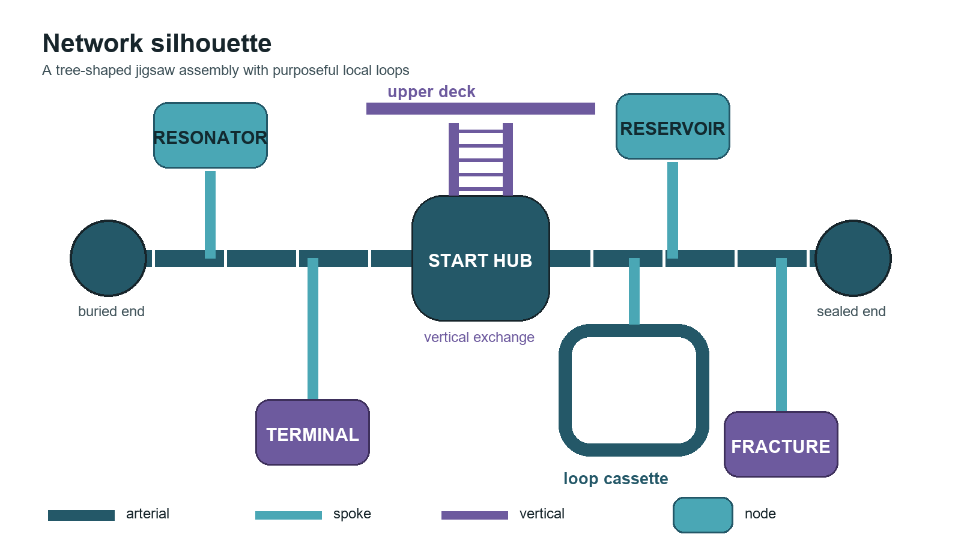
Figure 1 Proposed topology of trunks spokes hubs nodes and local loops

Standard corridor module
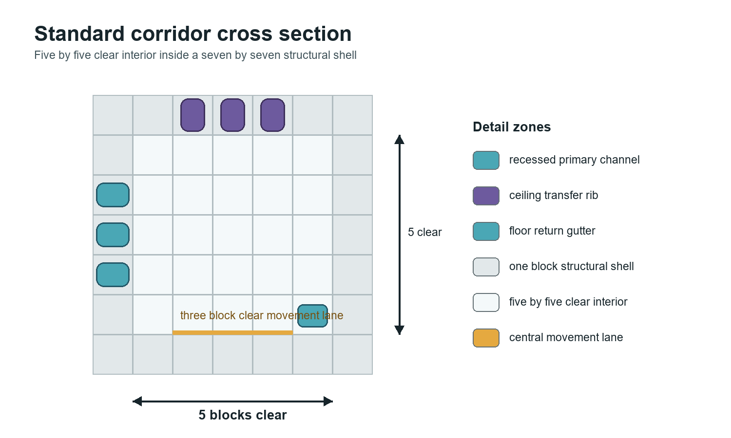
Figure 2 Five by five clear corridor inside a seven by seven structural shell
Use one consistent coordinate contract for every corridor throat.
Element | Dimension | Rule
Clear interior | 5 wide by 5 high | Keep the central three blocks free for movement and sightlines
Structural envelope | 7 wide by 7 high | Floor, ceiling, and one-block side shells sit outside the clear interior
Horizontal module | 8 blocks | Straight pieces use 8, 16, or 24 block multiples
Deck interval | 8 blocks | Vertical connectors move between repeatable floor datums
Connection aperture | 5 wide by 5 high | All horizontal jigsaw throats share the same opening
Detail depth | 1 block minimum | Recess most conduit detail into the structural shell rather than the walking lane

The floor datum is zero. The clear interior occupies vertical levels one through five, with the ceiling shell at six. Horizontal connector orientation should be aligned so that decorative bands, floor gutters, and left-right channel placement remain coherent after rotation.

Network silhouette
Each generated network should contain the following hierarchy:
1. A confluence hub starts the structure and establishes the local alignment.
2. Two opposed arterial trunks extend away from the hub in multi-piece runs.
3. Arterial pieces emit occasional spokes, bends, and a limited number of vertical transitions.
4. Spokes terminate in nodes, interfaces, damaged rooms, or intentionally sealed ends.
5. Hubs and loop cassettes create local cycles inside a single template, while the jigsaw assembly remains a tree.
This gives the player both legibility and uncertainty. Arterials are navigational anchors; spokes are where risk and reward live; hubs are recognizable decision points; nodes make endpoints feel purposeful.

Piece library

Arterial pieces
Arterials are the dominant mass of the network. They should be long enough to create anticipation and sparse enough in decoration to preserve the sightline.
Piece family | Suggested envelope | Function | Variants
Short straight | 7 by 7 by 8 | Rhythm break and collision-safe filler | left channel, right channel, ceiling channel
Standard straight | 7 by 7 by 16 | Primary trunk unit | intact, dormant, fractured, overgrown
Long straight | 7 by 7 by 24 | Rare dramatic sightline | lens gallery, ribbed conduit, broken span
Quarter bend | 11 by 7 by 11 | Direction change without pinching the interior | inner channel, outer channel
Offset bend | 15 by 7 by 11 | Shifts the trunk by one module | dry, flooded gutter
Arterial junction | 15 by 9 by 15 | Adds one spoke while preserving the trunk | left spoke, right spoke, opposed spokes

Every straight piece needs at least two detail variants that move the luminous band between wall, ceiling, and floor. A corridor should look like one flowing system, not the same decorated tube repeated end to end.

Hubs
Hubs are chambers where flow is divided, recombined, measured, or redirected. They should be recognizable from the approach before the player reaches their center.
Hub | Suggested envelope | Connections | Visual purpose
Confluence chamber | 17 by 11 by 17 | 4 horizontal and up to 2 vertical | Start piece and strongest navigational landmark
Distributor wheel | 23 by 11 by 23 | 4 to 6 internal spokes | Large radial floor diagram with a suspended focusing core
Splitter gallery | 15 by 9 by 23 | trunk plus 2 side spokes | Long hub that preserves arterial momentum
Vertical exchange | 15 by 17 by 15 | 2 horizontal and 2 vertical | Ladder stack wrapped around a central mana riser
Loop cassette | 23 by 9 by 31 | 2 external | Two parallel internal corridors joined at the far end

The distributor wheel and loop cassette provide the impression of a true network loop without asking the jigsaw solver to reconnect separate branches. All envelopes remain below the project pipeline's 48 block per-axis structure-piece limit.

Spokes and nodes
Spokes are shorter and denser than arterials. They carry stronger alignment colour and lead toward a specific terminal purpose.
Node | Suggested envelope | Read | Gameplay role
Resonator node | 13 by 9 by 17 | tuned crystal ribs around a focal lens | visual reward and modest decorative salvage
Regulator dais | 15 by 9 by 15 | carved valves and a ring floor | strong landmark and lore evidence
Mana reservoir | 15 by 11 by 19 | glass cisterns and overflow channels | light, water, and vertical interest
Survey shrine | 11 by 9 by 13 | map-like wall relief and calibrated marks | orientation clue and rare utility find
Fracture node | 17 by 13 by 21 | vitrified tear and displaced masonry | Faultwork bridge and environmental hazard
Sealed terminal | 9 by 7 by 9 | iris wall with a dead lens | common safe endpoint with no loot promise

Nodes should not become loot rooms. Most contain environmental evidence, a small amount of recoverable decorative material, or a route into another underground feature. A rare significant object must respect the era gates and the Twin Spines.

Vertical pieces
Use a repeatable eight-block deck interval. Vertical change should be obvious, safe enough to read, and varied enough that the network does not resemble a stack of identical mine ladders.
- Ladder stack: a seven-block outer shaft with landings, a central conduit, and a protected ladder wall.
- Offset riser: two short stairs or ledges around a thick conduit, changing both height and horizontal position.
- Broken drop: a damaged shaft with partial ladders, hanging roots or chains, and a visible lower landing.
- Reservoir climb: a wider shaft passing glass cells or trickling water, reserved for hub and node transitions.
A normal network should produce one to three vertical transitions and two to four occupied decks. Do not allow a vertical piece to emit another unrestricted vertical pool. Shafts should arrive at a landing that converts the next connection back to a horizontal spoke or arterial stage.

Jigsaw generation model

Staged pools
Use depth-named pools instead of a single recursively branching pool. This makes final pieces intentional and prevents the structure-size limit from leaving arbitrary open sockets.
Pool stage | Purpose | Allowed successors
leyline/start | Confluence hub variants | arterial_1, optional vertical_1
arterial_1 to arterial_3 | Establish two long trunks | next arterial stage, low-weight junction
arterial_4 to arterial_5 | Thin and bend the trunks | next arterial stage, spoke, hub, terminal
arterial_end | Finish the trunk | sealed terminal or buried break
spoke_1 to spoke_3 | Short branch chain | next spoke stage, node approach, vertical landing
spoke_end | Resolve a branch | node, interface, sealed terminal
vertical_1 | Change deck once | horizontal landing only
node | Terminal room | no unrestricted network sockets

The structure-level jigsaw depth can begin at size 7 with max_distance_from_center around 112 blocks and terrain_adaptation: none. These are starting values for fresh-world measurement, not production claims. Staged pools should close their own branches before the hard depth cap.

Starting weights
The first implementation pass can use these relative weights and tune them from generated samples.
Selection | Weight
Standard straight | 20
Short straight | 10
Long straight | 6
Quarter or offset bend | 8
Single-spoke junction | 5
Hub gateway | 2
Vertical exchange gateway | 2
Sealed or collapsed resolution | 7

Within spoke pools, increase node approaches and terminal resolutions while reducing long straights. Within later arterial stages, progressively increase bends and terminal weight. The exact distribution should be accepted by measured network footprints, branch counts, and collision rates rather than visual inspection of one favorable seed.

Connector contract
Use distinct names for topology roles so an arterial cannot accidentally accept a node entrance.
alfheim:ley_arterial_out -> alfheim:ley_arterial_in
alfheim:ley_spoke_out -> alfheim:ley_spoke_in
alfheim:ley_node_out -> alfheim:ley_node_in
alfheim:ley_vertical_up -> alfheim:ley_vertical_down
alfheim:ley_interface_out -> alfheim:ley_interface_in
Horizontal joints should be aligned. Connector apertures must share the same floor datum and five-by-five clearance. Jigsaw blocks must retire to ordinary air or a deliberate trim block, and the validator must reject exposed jigsaw blocks after assembly.

Placement proposal
The first tuning target is the Deepworks band from roughly Y minus 28 to Y minus 52. This overlaps quarry depth, remains above the lowest Faultworks, and allows vertical drops toward deeper ley wounds. Placement should use its own minecraft:random_spread structure set and a narrow Alfheim biome tag.
A starting density of about 48 chunks spacing with 20 chunks separation makes a network a substantial find instead of background scenery. Do not add it to the Greatbole spawn-protection structure family, whose 500-block exclusion is inappropriate for underground families.
The start site should require a solid-rock anchor volume. If the selected origin opens directly into a colossal cavern, use a supported bridge-start or wall-mouth start rather than hanging the confluence hub in empty space.

Architectural language

The channel is the subject
The passage exists to service the ley line. Put the magical infrastructure in the shell and let it repeatedly cross the player's route.
- A recessed primary channel occupies one wall for six to twelve blocks at a time.
- Transfer ribs cross the ceiling at four-block or eight-block intervals.
- A shallow return gutter or inlaid line runs along the opposite floor edge.
- Junctions widen the channel into lenses, forks, rings, or glass reservoirs.
- Broken sections expose a cool glowing vein behind the masonry instead of ordinary dirt and timber.
Reserve the center three blocks of the floor for movement. Detail may project into the two edge lanes at selected moments, but not continuously.

Material palette
Use a restrained base palette so emitted light remains legible.
Role | Primary materials | Use
Structural shell | Leyline Livingrock bricks and polished forms | 55 to 70 percent of authored masonry
Flow channel | Leyline carved forms and aligned Mana-glass | continuous directional line and focal lenses
Shadow border | Gloam Livingrock | one-block contrast band around channels and damaged apertures
Spark detail | Starfleck and Amethyst Livingrock | sparse ribs, node centers, and navigational marks
Damage transition | Cracked Livingrock and local Deepworks stone | breaches, repairs, and geology interfaces
Environmental intrusion | Moss, Rootbound, Tide, Frost, or Magmatic families | only where the surrounding formation justifies it

Do not distribute every livingrock family through one network. Choose one environmental intrusion family per structure or per coherent branch. Mana-glass alignment should likewise be stable across a node and its spokes.

Haze and light
Static structure blocks cannot create a reliable persistent fog volume on their own, so the first pass should produce haze through composition:
- keep most ambient light between levels two and six;
- place luminous blocks behind glass, grates, ribs, and partial occluders;
- break long sightlines with hanging roots, chains, thin waterfalls, and offset lens frames;
- use brighter nodes as silhouettes at the end of darker approaches;
- allow water mist and cave ambience from the surrounding Deepworks where naturally available.
Optional region particles or fog should be a later enhancement only if a runtime-proven API can confine them to the structure. The network must still read as hazy with particles disabled.

Condition states
Generate coherent condition packages, not independent random damage on every block.
State | Target share | Character
Dormant | 45 percent | intact masonry, faint Leyline light, silent lenses
Fractured | 25 percent | cracked bands, vitrified tears, unsafe drops
Overgrown | 15 percent | roots and moss entering from cooler vaults
Flooded | 10 percent | shallow water, Tide or Frost intrusion, broken reservoirs
Still active | 5 percent | brighter coherent pulse and the strongest navigational signal

Shares are structure-level starting targets. A branch may transition at a hub, but the condition should remain readable across several connected pieces.

Navigation and gameplay
The maze should be confusing in route choice but fair in memory.
- Arterials use two continuous light bands; spokes use one.
- Every hub has a unique floor or ceiling silhouette visible from its entrances.
- Vertical landings repeat a deck glyph and alignment colour.
- Nodes place their brightest feature opposite the entrance, making depth readable.
- Return-facing marks sit on the right wall when leaving the start hub, giving attentive players a breadcrumb convention.
Rewards should concentrate at nodes and interfaces, not in random corridor chests. Suitable finds include decorative Leyline stone, small aligned glass quantities, abandoned survey tools, minor consumables, and lore fragments. Avoid authored mob spawners in the first pass. Depth, darkness, broken traversal, and naturally wandering creatures provide the baseline danger.
The structure should reserve rare interface nodes for other Deep systems:
- Quarry interface: opens onto an exposed ore gallery without increasing ordinary ore everywhere.
- Tomb seal: a branch ends at Court masonry but does not guarantee access to a king's burial room.
- Faultwork breach: a fractured node terminates on a visible ley wound.
- Cavern bridge: an arterial crosses a large cavity on supported spans and rejoins solid rock.
These interfaces let the network explain how the ancient underground fit together while keeping each structure family mechanically distinct.

Implementation package
The eventual implementation should be generator-owned and parallel the project's existing structure pipeline.
tools/gen_leyline_channels.py
tools/check_leyline_channels.py
tools/leyline_channel_manifest.json
kubejs/data/alfheim/structures/leyline_channels/...
kubejs/data/alfheim/worldgen/template_pool/leyline_channels/...
kubejs/data/alfheim/worldgen/processor_list/leyline_channels/...
kubejs/data/alfheim/worldgen/structure/leyline_channel_network.json
kubejs/data/alfheim/worldgen/structure_set/leyline_channel_network.json
kubejs/data/alfheim/tags/worldgen/biome/has_leyline_channel_network.json
The generator should author geometry from shared corridor, socket, palette, and condition helpers. Straight-piece variants should be parameter changes rather than copied block lists. Re-running from the same manifest and source assets must be deterministic.

Validation and acceptance

Static gates
The checker should prove:
- every JSON file parses and every referenced pool, processor, and template exists;
- every connector target has at least one matching connector name;
- all horizontal throats preserve the five-by-five clear aperture and floor datum;
- vertical pieces preserve the eight-block deck interval;
- no piece exceeds 48 blocks on any axis;
- max_distance_from_center and terrain adaptation satisfy the codec limit;
- terminal stages carry no unrestricted continuation sockets;
- NBT palettes resolve to registered blocks and contain no unintended command blocks or spawners;
- all generated files match the manifest and generator output.

Runtime gates
Fresh-world validation should sample at least twenty located networks across multiple seeds and record:
- assembled piece count and bounding box;
- arterial length and branch count;
- occupied deck count and vertical reach;
- unconnected or exposed apertures;
- collision rejection rate by pool stage;
- percentage intersecting solid rock, caverns, lava, water, quarries, or other structures;
- remaining jigsaw blocks after generation;
- lighting, mob navigation, and player traversal failures.
The concept passes only when the median network reads as a trunk with spokes and nodes, not a pile of rooms, and when unfavorable seeds still terminate cleanly.

Visual review checklist
- From thirty blocks away, can the player identify the active direction of the channel?
- Does a five-by-five passage feel detailed without becoming cramped?
- Are long corridors interrupted before repetition becomes obvious?
- Can a player distinguish an arterial, spoke, hub, and node without labels?
- Do ladders and landings produce multiple levels without vertical spam?
- Does each branch use a coherent palette and damage state?
- Does darkness create haze and depth without making every surface unreadable?
- Do terminal pieces look designed even when they contain no reward?

First build slice
The smallest representative prototype is eleven templates:
1. One confluence start hub.
2. Two standard straight variants.
3. One long straight.
4. One quarter bend.
5. One single-spoke junction.
6. One ladder stack with landing.
7. One resonator node.
8. One fracture node.
9. One sealed terminal.
10. One buried-break terminal.
Wire these through staged pools, generate a sample grid for visual review, then place them in fresh worlds. The prototype should answer the difficult questions first: whether the five-by-five channel has enough visual density, whether the staged grammar produces long trunks, whether multi-level assembly remains clean, and whether the structure can meet caverns without appearing unsupported.
Only after that proof should the library expand into reservoirs, loop cassettes, quarry interfaces, tomb seals, and additional condition packages.

Final design test
The network succeeds when a player enters through a broken wall, follows a dim line through several long modules, realizes the line is splitting at a hub, descends beside the same conduit, and reaches a node whose architecture explains what the system once did. It should carry the exploratory rhythm of a mineshaft while looking like no mine was ever cut there.

